* It addresses particular readers.
  + Get information for section allows you to chose your sub-category based on who you are
  + Important dates allows you to see upcoming things on campus, addressing anyone on or around campus that may going to this website
  + Has sections for videos, pictures, and “explore campus” which should appeal to all types of people that would visit the BYUI.edu site.
* It helps readers solve problems.
  + It has an important links section, helping people get directly where they need to go
  + Important dates section allows people to see what’s coming up
  + University message section tells the user exactly what the page/school is about.
* It reflects the organization’s goals and culture
  + The site in general is very clean. Not a lot of fuss.
  + All pictures are of modestly dressed individuals
  + It is very clear that it is a university

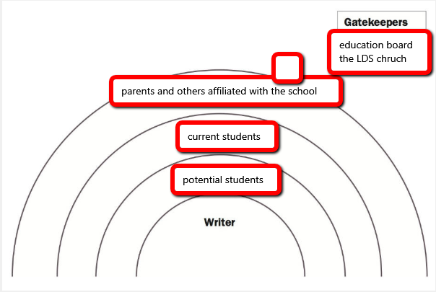

|  |  |  |  |
| --- | --- | --- | --- |
| Readers | Needs | Values | Attitudes |
| Primary | Find out about the school culture, and how to apply | Easy to find information, most pertinent info being the largest | Hopeful, excited |
| Secondary | Login to system, check deadlines | Efficiency and consistency | indifferent |
| Tertiary | Check things for children/students, check status of university | Easy to find information on student activity and university | Careful, concerned |
| Gatekeepers | Information is accurate, links work, conveys positive culture and entices potential students to apply. | Consistency in quality and culture of page. As well as with the other pages on the site. | Careful, positive |

The BYU-I home page is setup to convey a clear and concise message. It presents a culture of respect, modesty and happiness without being overbearing. It stays consistent with the general style and theme of the rest of the website. It’s primary purpose is to redirect the user to somewhere else more useful for them on the BYUI.edu domain. It’s primary users are potential and current students, with a tertiary audience of parents and staff. It plays into the values at BYU-I of realizing one’s potential and having a place to belong, with the largest images on the page stating just that.